Building Guide Mode Instructions (Lego Digital Designer)

Project: ECSE 211 Search & Retrieval Robot
Document Version Number: 1.1
Date: April 7, 2020
Author: Yazdan Zinati

Edit History:
Date | Version | Author(s) | Changes
Apr 6 | 1.0 | Yazdan Zinati | First draft
Apr 6 | 1.1 | Yazdan Zinati | Added pictures

Step 1
Open Lego Digital Designer from the desktop or the application menu.



Step 2
Select “File” from the toolbar and click on “import model (Ctrl+l)”.

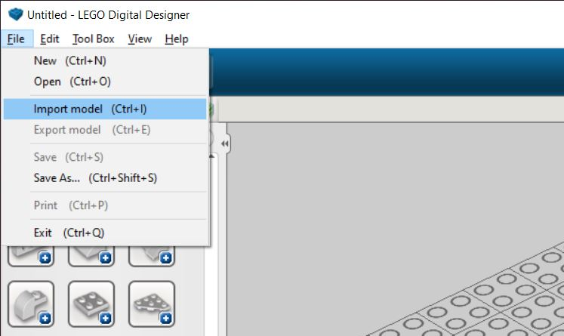

Step 3
Navigate to the model directory, select the model (LXF file) and click on “Open”.

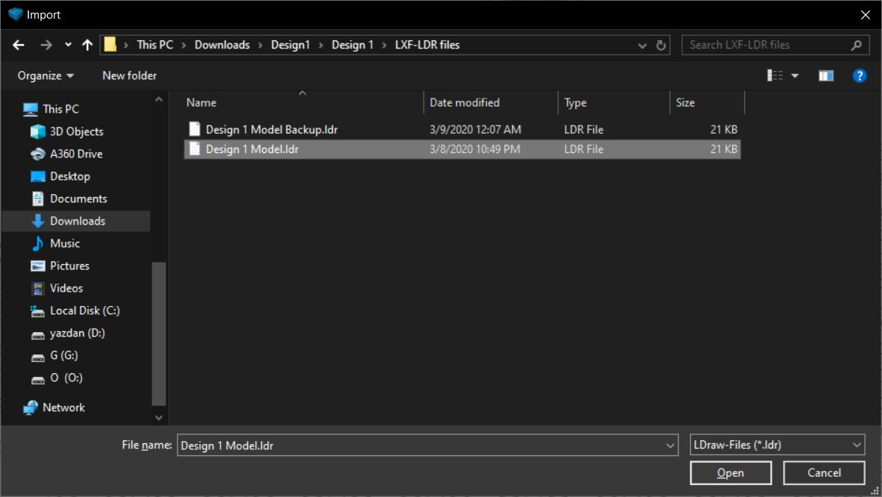

Step 4
Select “Building guide mode (F7)” from the top menu.
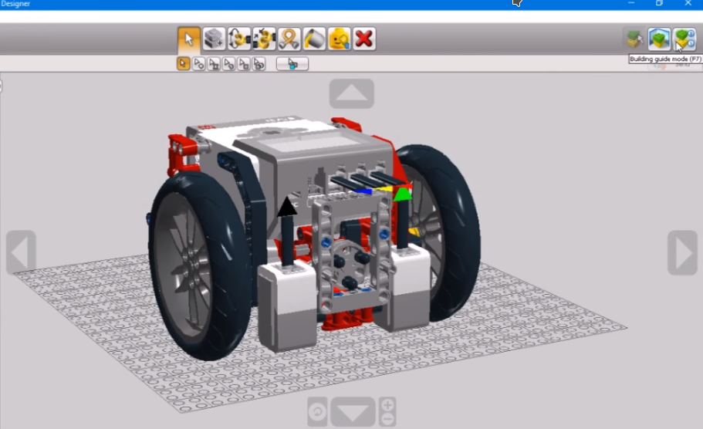

The Building Guide mode gives you access to the Building Guide player, which you can use to play through the different steps in your building guide.


Next/Previous Step (Right and Left Arrow keys): Go one step forward or backward in the building guide


Repeat Last Step (Spacebar): Play the last step again

Step Slider: Displays your current step number and the total number of steps in your building guide.

Step Counter: Displays your current step number and the total number of steps in your building guide

Assembly View: Reveals a preview of your next 4 bricks

